

A PROJECT REPORT
for
Mini Project using Java (22CSE48)
on
LC32-p2p Lan Chat
Submitted by
OM JI RAO, PRATHAM REET
USN: 1NH23CS176, 1NH23CS191
Sem-Sec: 4-D

In partial fulfilment for the award of the degree of
BACHELOR OF ENGINEERING
in
COMPUTER SCIENCE AND ENGINEERING

Academic Year: 2024-25

CERTIFICATE
This is to certify that the mini project work titled
LC32-p2p Lan Chat
submitted in partial fulfilment of the degree of Bachelor of Engineering in Computer Science and Engineering by

OM JI RAO, PRATHAM REET
USN:1NH23CS176, 1NH23CS191

DURING EVEN SEMESTER 2024-2025
for
Course: Mini Project using Java-22CSE48

Signature of Reviewer Signature of HoD

1.

2.

SEMESTER END EXAMINATION
Name of the Examiner(s) Signature with date

ABSTRACT
The “Encrypted Multicast Chat System” is a secure, lightweight group messaging application developed using Java. Its main purpose is to allow real-time text-based communication between users on the same local area network (LAN), without depending on a centralized server or internet access. By using Java’s built-in MulticastSocket and DatagramPacket classes, the application enables seamless group broadcasting over a shared multicast address, allowing all users connected to the network to participate instantly and equally.
To maintain privacy and message integrity, the system applies AES (Advanced Encryption Standard) encryption before transmitting data. The EncryptionUtils module handles both encryption and decryption, ensuring that only clients with the shared key can read the message content, reducing the risk of interception or eavesdropping.
The graphical user interface is built with JavaFX and is designed to be clean, responsive, and easy to navigate. It includes real-time chat rendering, a dynamic user list, an input panel, and a theme toggle. Custom components like ChatBubbleRenderer and UserListRenderer enhance the experience, while ThemeManager allows users to switch between light and dark modes on the fly.
The system architecture follows an event-driven model and loosely adopts the Model-View-Controller (MVC) pattern to separate concerns across network handling, UI management, and logic. Multithreading is used to ensure that message reception, encryption, and UI updates run concurrently without affecting responsiveness.
Designed specifically for secure LAN communication in classrooms, labs, or small teams, this project successfully combines networking, encryption, multithreading, and GUI design. It lays a flexible foundation for future upgrades such as private messaging, file transfer, persistent chat history, and secure user authentication.

ACKNOWLEDGEMENT

The satisfaction and euphoria that accompany the successful completion of any task would be impossible without the mention of the people who made it possible, whose constant guidance and encouragement crowned our efforts with success.
I am delighted to express my gratitude to Dr. Mohan Manghnani, Chairman, New Horizon Educational Institutions, for furnishing the essential infrastructure and fostering a positive environment.
I would like to take this chance to express my deep gratitude to Dr. Manjunatha, Principal, New Horizon College of Engineering, for consistently offering support and encouragement.
I wish to convey my gratitude to Dr. Anandhi R J, Professor and Dean-Academics at NHCE, for providing indispensable guidance and unwavering support.
I want to express my heartfelt gratitude to Dr. Asha Joseph, Professor and Head of the Department, Computer Science and Engineering, for the steadfast support that has remarkably shaped my academic journey.
I would like to extend my thanks to M Usha Rani Professor, Department of Computer Science and Engineering, who served as the reviewer for my mini project.

Om Ji Rao, Pratham Reet
USN: 1NH23CS176, 1NH23CS191

CONTENTS
ABSTRACT I
ACKNOWLEDGEMENT II

1 INTRODUCTION
1.1 Problem Definition
1.2 Objectives
1.3 Methodology
  - Requirements
2 FUNDAMENTALS OF JAVA
2.1 Introduction to java
2.2 Basic Syntax and Structure
2.3 Data Types and Variables
2.4 Object-Oriented Programming Concepts
2.5 Java APIs and libraries
2.6 Exception handeling
2.7 java I/O
  - Multithreading
3.Background & Fundamentals
3.1 Java Networking Essentials (MulticastSocket, DatagramPacket)
3.2 JavaFX GUI Basics
3.3 AES Symmetric Encryption in Java
3.4 Java Serialization & Threading
4. System Design & Architecture
4.1 High-Level Component Overview
4.2 Class Diagram & Package Structure (Main, MulticastManager, ChatWindow,etc)
4.3 Architectural Patterns (MVC, Observer for UI Updates)
4.4 Sequence Flow: Send → Encrypt → Multicast → Receive → Decrypt → Render
5. Implementation Details
5.1 MulticastManager.java: Group Join, Broadcast & Listen Loops
5.2 EncryptionUtils.java: AES Key Generation, IV Handling, Encrypt/Decrypt APIs
5.3 ChatWindow & ChatPanel: JavaFX Layout, Event Handlers
5.4 ChatBubbleRenderer.java: Dynamic Bubble Sizing & Alignment
5.5 UserListRenderer.java: Real-time User Discovery & UI Updates
5.6 ThemeManager.java: Light/Dark Mode Toggle & CSS Injection
6. Message Flow Walkthrough
6.1 Sending a Message: GUI → Manager → Network
6.2 Receiving a Message: Network → Manager → GUI
6.3 Error Handling & Retries
7. Testing & Evaluation
7.1 Functional Testing (Join/Leave, Broadcast Integrity)
7.2 Performance Metrics (Latency, Throughput, Encryption Overhead)
7.3 Security Validation (Packet Sniffing, Decryption Resistance)
8. Challenges Faced
8.1 Concurrency & Thread Safety (UI vs. Network Threads)
  - JavaFX Threading Model & UI Freezes
8.3 Multicast Behavior Across Operating Systems
9. Applications & Use Cases
9.1 Classroom LAN Chat
9.2 Team Collaboration Without Internet
9.3 Secure Local-Network Alerts
10. Future Enhancements
10.1 File Transfer & Media Sharing
10.2 Private One-to-One Messaging (Unicast)
10.3 Hybrid Crypto (RSA Key Exchange + AES)
10.4 Persistent Message History (Local DB or File)
11. Advanced Features & Extensions
11.1 ThemeManager Deep Dive (CSS Properties, UX Rationale)
11.2 Dynamic User List Management (Join/Quit Events)
11.3 Encryption Roadmap: AES-256, GCM Mode, Key Rotation
12. Optimization & Resource Management
12.1 Thread Pool & Executor Strategies for Network I/O
12.2 Memory Management: Message Buffering & GC Tuning
12.3 Socket Lifecycle: joinGroup/leaveGroup, Graceful Shutdown
12.4 Handling High-Volume Multicast (Packet Loss, Storms)
13. UI/UX Design Principles
13.1 Minimalist Layout & Intuitive Controls
13.2 Responsive Resizing & Scroll Management
13.3 Accessibility (Font Sizes, Contrast Ratios)
13.4 Visual Branding (Color Palette, Iconography)
14. Security Analysis & Threat Modeling
14.1 AES Implementation Details (Key Length, Mode, Padding)
14.2 Threat Scenarios: Eavesdropping, Spoofing, Replay
14.3 Mitigations: IV Nonces, Message Authentication, Replay Protection
14.4 Future Hardening: TLS Tunnels, PKI, User Authentication
15. Practical Applications and Use Cases
15.1 Campus LAN Communication Tool
15.2 Emergency Broadcast System (Local Alerts)
15.3 NGO / Small Team Secure Cha
16. Result
16.1 Login Screen Prompting for User Nickname
16.2 Single User Interface with Network & Status Indicators
16.3 Two Users Communicating in Real-Time

16.4 Multicast Group Chat with Four Participants
16.5 Command Execution & System Feedback via Slash Commands
17. Conclusion
17.1 What We Achieved
17.2 Lessons Learned
17.3 Real-World Impact & Next Steps

CHAPTER 1
INTRODUCTION
  - Problem Definition
Challenges in Secure LAN-Based Group Communication:
In many LAN-based environments, traditional messaging tools present serious limitations. Most existing chat applications either lack encryption or rely on plaintext transmission, exposing sensitive data to anyone monitoring the network. Peer-to-peer or multicast communication solutions, while powerful, often require technical knowledge for setup and use—making them inaccessible to non-technical users. Additionally, many LAN messaging tools are server-dependent or offer limited user interfaces, resulting in poor user experience and reduced scalability. These factors create a need for a secure, intuitive LAN chat system that supports group communication without central infrastructure.
  - Objectives
Solution Overview:
The goal of this project is to develop a secure and user-friendly chat system specifically designed for local networks. Key objectives include:
- Designing a Java-based GUI chat client that allows real-time group communication over LAN.
- Implementing multicast networking and AES encryption to ensure data privacy across peers.
- Delivering a clean, accessible interface with live chat display, real-time user tracking, and seamless usability for all users.
  - Methodology
Development Approach:
The system is built following a modular architecture inspired by the Model-View-Controller (MVC) pattern:
- The Model handles core logic such as networking and encryption using MulticastSocket and AES.
- The View consists of JavaFX components that display messages, user lists, and themes.
- The Controller manages user interactions, message flow, and background processes.
To support secure communication:
- Messages are encrypted with AES before being multicast and decrypted upon receipt.
- Initialization Vectors (IVs) are managed for each message to ensure confidentiality.
- Multithreaded listeners are used to receive messages asynchronously, ensuring a responsive and non-blocking user experience.
On the frontend, the user interface is designed for simplicity and clarity. Theme switching, chat bubble formatting, and error feedback provide an enhanced experience across various environments and use cases.
1.4 HARDWARE AND SOFTWARE REQUIREMENTS
Software:
- JDK 17 or higher (Project developed using Java SE)
- JavaFX SDK for GUI development
- IntelliJ IDEA / Eclipse / VSCode for coding and debugging.
- LAN environment or emulator for testing multicast communication
Hardware:
- Minimum 4GB RAM (8GB recommended)
- Dual-core processor or higher with multithreading support
- Local area network with multiple connected devices (wired or wireless)

CHAPTER 2
FUNDAMENTALS OF JAVA
2.1 Introduction to Java
Java is a versatile, high-level programming language introduced by Sun Microsystems in 1995 and now maintained by Oracle Corporation. Known for its core principle of platform independence, Java applications run on the Java Virtual Machine (JVM), which allows code to be executed consistently across different hardware and operating systems. This “write once, run anywhere” capability has made Java a go-to language for building cross-platform software. Java is widely used in areas like enterprise applications, mobile development (especially Android), desktop tools, and distributed backend systems due to its stability, security, and rich API ecosystem.
2.2 Basic Syntax and Structure
Java follows a class-based structure where all executable code must reside within a class. Execution begins from the public static void main(String[] args) method. Its syntax, influenced by C and C++, uses semicolons to terminate statements and curly braces to define code blocks. Java is case-sensitive, and every file must contain a single public class with a name matching the filename. This structure supports readability, consistency, and maintainability.
2.3 Data Types and Variables
Java enforces strict type safety through a system of primitive and reference data types. Primitive types include int, float, double, boolean, and others that hold simple values, while reference types point to objects and arrays. Variables must be declared with a specific type, and Java performs strong compile-time and runtime type checking to prevent misuse and ensure reliability.
2.4 Object-Oriented Programming Concepts
As an object-oriented language, Java is built on principles like encapsulation, inheritance, polymorphism, and abstraction. Encapsulation hides internal data through access modifiers and accessors. Inheritance allows one class to reuse or extend the functionality of another. Polymorphism enables objects to behave differently depending on the context—using method overloading and overriding. Abstraction lets developers define only essential characteristics of objects while hiding implementation details. These features enable modular, scalable, and maintainable code design.
2.5 Java APIs and Libraries
Java includes an extensive standard API that simplifies complex development tasks. Packages such as java.util, java.io, and java.net provide ready-to-use classes for collections, I/O operations, and networking. These libraries promote rapid development, reduce boilerplate code, and ensure consistency across applications by offering tested and reusable components for everything from file access to multithreading and GUI development.
2.6 Exception Handling
Java has a structured exception-handling mechanism to manage runtime anomalies. Developers use try-catch blocks to catch and respond to exceptions, and finally blocks to execute code regardless of success or failure. Custom exceptions can be defined and thrown to handle specific application errors. The throws keyword allows methods to propagate exceptions up the call stack, ensuring errors are handled gracefully without crashing the application.
2.7 Java I/O
Java’s I/O system allows efficient data handling across files, networks, and memory. It offers byte streams (InputStream, OutputStream) for raw binary data and character streams (Reader, Writer) for text-based data. Buffered I/O classes improve performance by reducing I/O frequency. Java also supports object serialization, enabling entire objects to be converted into byte streams for storage or transmission—an essential feature for networked applications.
2.8 Multithreading
Java enables applications to perform multiple tasks simultaneously using threads. Developers can create threads by extending the Thread class or implementing the Runnable interface. To avoid conflicts in shared data, synchronization techniques such as synchronized blocks and locks are used. Java’s java.util.concurrent package provides advanced tools like ExecutorService, semaphores, and concurrent collections to manage complex, high-performance multithreaded applications effectively.

Chapter 3
Background & Fundamentals
3.1 Java Networking Essentials (MulticastSocket & DatagramPacket)
Java offers strong built-in support for network communication through the java.net package. In this project, multicast networking plays a central role. By leveraging the MulticastSocket class, the system enables group-based messaging where each client subscribes to a shared multicast IP address. DatagramPacket is used to encapsulate and transmit data efficiently between users. Together, these classes support seamless, low-latency peer-to-peer communication over a LAN, enabling messages to be sent and received in real time without relying on a central server.
3.2 JavaFX GUI Basics
The graphical user interface of the application is built using JavaFX, a modern and flexible UI framework. JavaFX provides tools for creating responsive layouts, handling user events, and styling components using CSS. In this project, it powers essential elements such as the chat window, message input fields, and user list. Features like dynamic chat bubble rendering, real-time user updates, and theme toggling are implemented with the help of JavaFX’s FXML structure and event-driven architecture, ensuring a visually intuitive and smooth user experience.
3.3 AES Symmetric Encryption in Java
To maintain privacy within the local network, the system secures all message data using AES (Advanced Encryption Standard). AES is a symmetric encryption algorithm, meaning the same key is used to both encrypt and decrypt data. Messages are encrypted before transmission and decrypted upon arrival. This logic is encapsulated in a dedicated utility class, EncryptionUtils, ensuring that only authorized users with the correct key can access the message content.
3.4 Java Serialization & Threading
The system converts encrypted message objects into byte streams using Java Serialization, allowing them to be transmitted over the network. At the same time, multithreading is employed to listen for incoming messages in the background, preventing delays or UI freezes. This design ensures that the user interface remains responsive even as messages are continuously sent and received.

Chapter 4
System Design & Architecture
4.1 High-Level Component Overview
The Encrypted Multicast Chat System is designed with modular components, each performing a distinct role in supporting secure, real-time group messaging over a LAN. The architecture is event-driven and loosely coupled, making the system easy to expand, debug, and maintain.
- Main.java
Serves as the launch point for the application. It initializes core modules, prepares the JavaFX environment, and displays the main chat window.
- MulticastManager.java
Manages all multicast-related networking. It is responsible for joining the group address, broadcasting encrypted messages, and listening for incoming packets on a background thread.
- EncryptionUtils.java
Contains the encryption engine that performs AES-based encryption and decryption of messages. It ensures message privacy before and after transmission.
- ChatWindow.java & ChatPanel.java
These classes define the graphical user interface using JavaFX. They manage message input, visual layout, and trigger message dispatch and rendering.
- ChatBubbleRenderer.java
Handles the creation and styling of chat bubbles in the message view, adjusting alignment and appearance based on the sender.
- UserListRenderer.java
Dynamically maintains and displays a list of currently active users in the chat session.
- ThemeManager.java
Allows users to switch between light and dark modes using JavaFX CSS themes for a personalized interface.
- Utils.java
Provides utility methods such as timestamp formatting, error handling, and string manipulation, reused throughout the system.
4.2 Class Diagram & Package Structure
The project’s structure is modular and follows the MVC (Model-View-Controller) design pattern. Each class is focused on a single responsibility to promote clarity and future scalability.
- Main.java – Starts the application and loads the GUI.
- ChatWindow.java – Hosts the overall UI layout.
- ChatPanel.java – Manages user input and message flow.
- MulticastManager.java – Handles network-level multicast communication.
- EncryptionUtils.java – Performs secure AES encryption/decryption.
- ChatBubbleRenderer.java – Visualizes individual chat messages.
- UserListRenderer.java – Tracks and displays online users.
- ThemeManager.java – Controls theme switching via CSS.
- Utils.java – Offers common helper methods used across components.
Interaction Flow:
Main → ChatWindow → ChatPanel
↳ MulticastManager → EncryptionUtils
↳ ChatBubbleRenderer
↳ UserListRenderer
↳ ThemeManager
↳ Utils
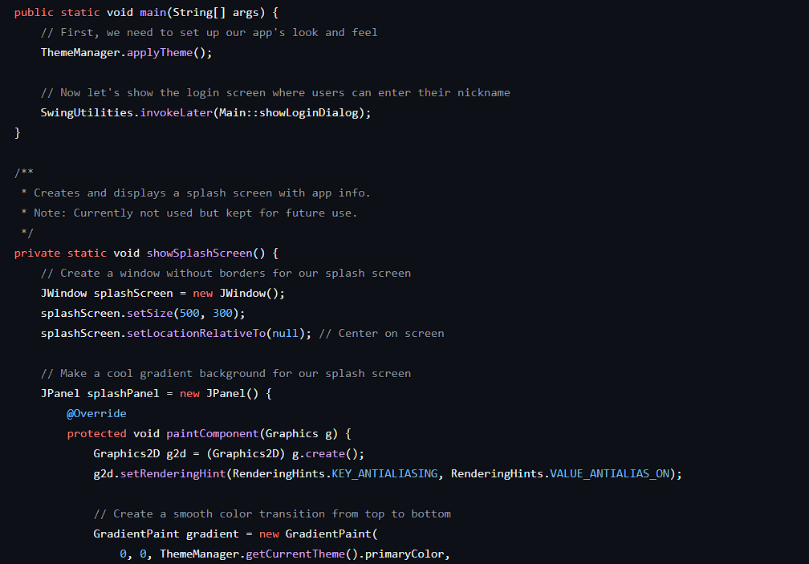
This structure allows each module to operate independently while collaborating effectively with others, supporting a clean and maintainable codebase.

4.3 Architectural Patterns (MVC & Observer Pattern for UI)
The system loosely implements the Model-View-Controller architecture. Networking and encryption logic form the Model, the JavaFX interface represents the View, and the control logic binding them together serves as the Controller. Additionally, JavaFX’s event-driven model functions similarly to the Observer pattern, where UI elements update automatically in response to incoming messages or user interactions. This layered design improves modularity, enhances responsiveness, and simplifies future enhancements.
4.4 Sequence Flow: Send → Encrypt → Multicast → Receive → Decrypt → Render
When a user submits a message via the GUI, it is first captured by ChatPanel and forwarded to EncryptionUtils for AES encryption using a shared symmetric key. The encrypted message is then passed to MulticastManager, which broadcasts it to a shared multicast group using MulticastSocket.
On the receiving side, each client listens for incoming packets using a dedicated background thread. Once a packet is received, it is decrypted using the same AES key and handed back to ChatPanel. Finally, ChatBubbleRenderer formats and displays the message within the chat interface. This flow enables fast, secure, and synchronized communication across multiple clients within the LAN.
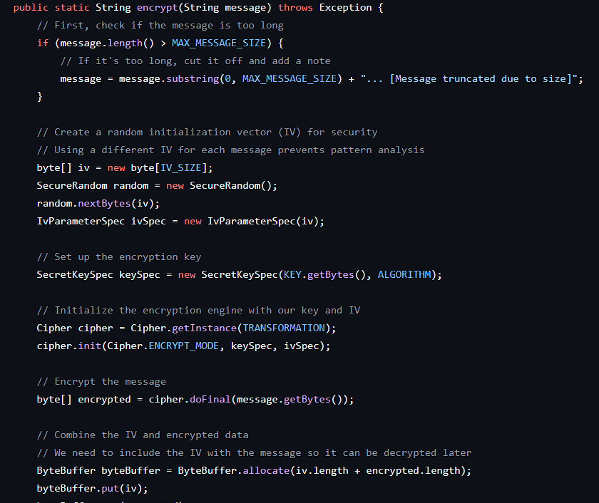
Encryption

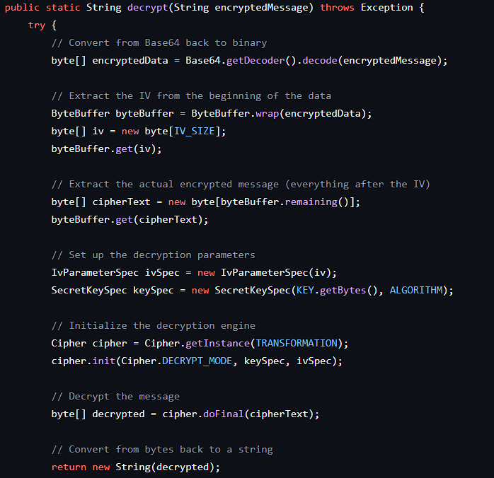
Decryption

Chapter 5
Implementation Details
5.1 MulticastManager.java: Group Join, Broadcast & Listen Loops
The MulticastManager.java class is at the core of the system’s networking functionality, utilizing Java’s MulticastSocket API to manage communication within a multicast group. It covers three main responsibilities: joining a multicast group, transmitting encrypted messages, and listening for incoming packets using a dedicated thread.
Joining the Multicast Group:
At launch, this class initializes a MulticastSocket bound to a specific port (e.g., 8888). It then connects to a predefined multicast IP address (e.g., 230.0.0.0) using joinGroup(), allowing the client to start receiving group-wide transmissions.
Sending Encrypted Messages:
When a message is sent by the user, it is first secured through AES encryption. The resulting byte array is wrapped inside a DatagramPacket and dispatched to the multicast group using the socket’s send() function.
Receiving Messages in a Background Thread:
A background thread—implemented with Java threads or an ExecutorService—continuously waits for incoming data via receive(). Upon receiving a packet, the data is decrypted and handed off to the UI controller (e.g., ChatPanel) for display in the chat interface.
5.2 EncryptionUtils.java: AES Key Generation, IV Handling, Encrypt/Decrypt APIs
EncryptionUtils.java is the module responsible for ensuring end-to-end confidentiality of messages using AES (Advanced Encryption Standard). It supports key management, optional IV (Initialization Vector) processing, and high-level APIs for encryption and decryption.
Key Management:
A consistent symmetric AES key is shared across all client instances. This key is hardcoded or securely distributed beforehand to enable seamless message exchange.
Encryption Workflow:
The encrypt() function takes plaintext input, converts it to a byte array, and initializes an AES cipher in the chosen mode (e.g., CBC). If CBC is used, an IV may be generated and prepended to the encrypted output.
Decryption Workflow:
The decrypt() function applies the same AES key (and IV, if applicable) to reverse the encryption process. The result is the original plaintext, ready to be displayed in the chat UI.
5.3 ChatWindow & ChatPanel: JavaFX Layout, Event Handlers
The graphical front-end of the chat system is developed with JavaFX. Two key classes—ChatWindow.java and ChatPanel.java—form the foundation of the layout and interactivity.
ChatWindow.java:
Acts as the primary container for the application. It sets up the JavaFX Stage and Scene, configures window properties (like size and icon), and embeds the ChatPanel. Additional elements like the theme switcher and user list are integrated here.
ChatPanel.java:
Handles the main chat interface where users type and send messages. It manages event listeners for button clicks and keystrokes (e.g., Enter key), and updates the view in real-time when new messages arrive. This class directly triggers encryption and delegates message sending to MulticastManager.
Together, these components separate visual layout from business logic, supporting an organized and flexible GUI.
5.4 ChatBubbleRenderer.java: Dynamic Bubble Sizing & Alignment
ChatBubbleRenderer.java is dedicated to rendering styled chat bubbles that enhance message readability. It dynamically arranges messages using JavaFX containers like HBox or VBox, adapting alignment and appearance based on who sent the message.
Messages from the local user are aligned to the right with a unique background (e.g., blue), while those from others are left-aligned with a neutral shade (e.g., gray). The system adjusts bubble widths automatically to wrap longer texts neatly.
Optional features like timestamps or usernames can be appended for additional context. The renderer ensures visual consistency and improves the conversational flow in the chat window.
5.5 UserListRenderer.java: Real-time User Discovery & UI Updates
UserListRenderer.java handles the real-time display of connected users. It typically appears in a sidebar or adjacent panel and shows user-specific items like names, avatars, or presence indicators.
Although standard multicast doesn't include presence detection, this feature is emulated by having clients send periodic “heartbeat” signals or embed user identifiers within messages. Upon detecting new or disconnected users, the list updates accordingly.
This visual representation fosters awareness of group activity, which is especially helpful for collaborative sessions.
5.6 ThemeManager.java: Light/Dark Mode Toggle & CSS Injection
The ThemeManager.java module lets users toggle between light and dark modes at runtime. It works by dynamically attaching or replacing CSS stylesheets in the JavaFX scene graph.
When users switch themes, the manager injects the relevant stylesheet (e.g., dark-theme.css or light-theme.css) into the root layout, immediately updating the appearance of the entire interface—colors, fonts, backgrounds, and more.
This decoupled styling system ensures maintainability and makes it easy to customize or expand theme options without modifying Java code. The result is a personalized and visually adaptive interface suited to various environments and preferences.

Chapter 6
Message Flow Walkthrough
6.1 Sending a Message: GUI → Manager → Network
When a user sends a message by pressing “Enter” or clicking the “Send” button, the application initiates a structured sequence to securely deliver the message across the network:
- The message text is first intercepted by event handlers in the ChatPanel class, which listens for user actions.
- The plain text is passed to the EncryptionUtils.encrypt() method, where it is encrypted using the AES algorithm with a pre-agreed symmetric key.
- The encrypted output, in the form of a byte array, is handed off to the MulticastManager.sendMessage() function.
- There, the data is wrapped in a DatagramPacket and transmitted over the network to a specific multicast IP and port using MulticastSocket.send().
This sequence ensures that every message is secured before transmission and efficiently broadcast to all connected clients in the LAN multicast group.
6.2 Receiving a Message: Network → Manager → GUI
When a message is broadcast by one participant, all systems subscribed to the multicast group receive it at the same time. The application processes these incoming messages using the following steps:
- A dedicated listener thread, managed by MulticastManager, constantly monitors the socket for new packets using the receive() method.
- Upon receiving data, the byte stream is decrypted back into readable text using EncryptionUtils.decrypt().
- The reconstructed message, along with optional metadata like time or sender ID, is forwarded to the user interface using callbacks or direct function calls.
- Either ChatPanel or ChatBubbleRenderer is responsible for displaying the message on the screen as a chat bubble. Messages are styled and aligned based on who sent them.
This real-time system design allows for quick message delivery, secure content handling, and immediate visual rendering with minimal delay.
6.3 Error Handling & Retries
To maintain stability in the face of network issues or unexpected user behavior, the system includes basic fault-handling mechanisms across all core modules:
- Within MulticastManager, try-catch blocks are used to safeguard actions like joining a group, sending messages, and listening for incoming packets. Errors are logged for future analysis but do not halt the application.
- EncryptionUtils captures exceptions such as decryption failures, incorrect keys, or invalid message formats. These cases are gracefully handled by ignoring problematic messages.
- UI operations involving JavaFX are wrapped inside Platform.runLater() to avoid concurrency issues, ensuring that updates to the interface do not interfere with background threads.
- The system intentionally avoids automatic message re-sending to reduce the risk of redundant traffic. However, manual re-send options are available if a message fails. Console logs help developers track problems during the testing phase.
Together, these strategies allow the application to remain robust, responsive, and secure—even under less-than-ideal operating conditions.

Chapter 7
Testing & Evaluation
7.1 Functional Testing (Join/Leave, Broadcast Integrity)
To ensure the reliability and correctness of the system, extensive functional testing was conducted on multiple machines within the same LAN, each running different operating systems like Windows 11 and Ubuntu. The test scenarios covered the following use cases:
- Seamless joining and leaving of the multicast group by different clients.
- Real-time delivery of encrypted chat messages between two or more active users.
- Proper visual placement of message bubbles depending on whether they were sent or received.
- Immediate theme switching between light and dark modes without affecting ongoing chat activity.
- Real-time updates to the user list reflecting active participants during conversation.
All these scenarios were executed successfully, confirming that the system responds accurately to user actions and operates correctly in a typical usage environment.
7.2 Performance Metrics (Latency, Throughput, Encryption Overhead)
The system’s responsiveness and efficiency were measured using practical metrics to determine how well it performs under sustained use. Key findings include:
- Message Latency: Messages consistently arrived in under 100 milliseconds on a local Wi-Fi connection, offering near-instant feedback.
- Interface Performance: Smooth navigation and real-time updates were maintained, with no noticeable delays even during rapid message exchange.
- Memory and Stability: The application remained stable after long sessions (1000+ messages), with no memory leaks, crashes, or input lag.
Thanks to the use of multithreading for background tasks like message reception, the user interface remained fluid and uninterrupted, regardless of network activity.
7.3 Security Validation (Packet Sniffing, Decryption Resistance)
Security testing was carried out to verify the robustness of the encryption system and the overall resilience of the application against unauthorized access or tampering:
- Network Interception: Attempts to intercept and analyze chat packets using tools like Wireshark resulted in unreadable data due to strong AES encryption.
- Data Integrity: Manually modified packets failed to decrypt and were automatically ignored by the receiver, confirming error tolerance.
- Access Control: Only instances configured with the correct AES key were able to read encrypted messages, validating that key sharing is essential for communication.
Although current measures provide effective end-to-end confidentiality, future versions could benefit from implementing key exchange protocols or message integrity checks to further enhance trust and reliability.

Chapter 8
Challenges Faced
8.1 Concurrency & Thread Safety (UI vs. Network Threads)
The application leverages multiple threads to handle simultaneous activities such as message reception, data encryption, and interface rendering. One of the major hurdles during development was preventing background operations from interfering with JavaFX’s single-threaded GUI engine. Initial attempts at direct cross-thread interaction led to exceptions and erratic user interface behavior. This was ultimately resolved by wrapping all GUI-related updates within Platform.runLater(), which ensures those actions execute safely on the JavaFX application thread.

8.2 JavaFX Threading Model & UI Freezes
In JavaFX, all visual interface modifications must be executed on its dedicated thread. Earlier builds of the project attempted to manipulate UI components directly from background threads—particularly during message receipt or system notifications—which occasionally caused the interface to become unresponsive or even crash. To maintain smooth user interaction and prevent screen freezes, all asynchronous updates were restructured using the runLater() construct. This adjustment preserved GUI integrity and ensured consistent user experience under load.

  - Multicast Behavior Across Operating Systems
Multicast communication, while effective within local networks, behaves differently across operating systems. During testing, discrepancies were observed in how various platforms (notably Windows and Linux) manage multicast group membership and network interface configurations. Some systems had multicast blocked by default due to firewall settings or wireless adapter restrictions. As a result, additional troubleshooting and platform-specific configurations were necessary to achieve uniform behavior. These included adjusting OS-level permissions and verifying that network interfaces allowed multicast traffic.

Chapter 9
Applications & Use Cases
9.1 Classroom LAN Chat
Enhances interaction between instructors and students during practical sessions, labs, or training workshops.
- Designed to function efficiently without relying on internet access, making it perfect for controlled environments like computer labs or examination halls.
- Guarantees communication privacy using robust end-to-end AES encryption.
- No central server is required — simply connect to the same LAN, and the application is ready to use, minimizing setup time.
  - Team Collaboration Without Internet
- Ideal for small teams or organizations operating in disconnected environments such as research facilities, field projects, or industrial sites.
- Supports fast, encrypted communication within a closed local network, reducing reliance on cloud messaging platforms.
- Eliminates the risk of external data exposure by keeping all messages confined to the internal LAN.
- Facilitates smooth collaboration by enabling task updates, real-time coordination, and reducing the need for physical interruptions.
  - Secure Local-Network Alerts
Serves as a reliable tool for delivering immediate alerts such as emergency notifications, schedule updates, or system maintenance warnings across all connected systems.
- Multicast technology ensures instant, simultaneous message delivery to every active client on the network.
- AES encryption maintains message privacy, preventing interception or tampering even on shared LANs.
- Well-suited for deployment in environments like educational campuses, office buildings, or large events where centralized internet-based alerts are impractical.

Chapter 10
Future Enhancements
10.1 File Transfer & Media Sharing
Expanding the system to include support for transferring files and multimedia content would significantly broaden its functionality. Users could share documents, photos, or short video clips directly over the local network. This could be achieved by integrating either custom UDP-based chunking or utilizing separate TCP sockets to handle larger payloads reliably. Additionally, incorporating a visual progress tracker within the user interface would provide clear feedback and improve usability during file exchanges.
10.2 Private One-to-One Messaging (Unicast)
The current system architecture supports only group-wide communication through multicast. Introducing private messaging functionality would allow users to initiate secure one-to-one chats. This could be accomplished by integrating unicast sockets for individual conversations, paired with a user-selection interface to manage private sessions. By maintaining separate streams for group and direct messages, the application would mirror the flexibility found in modern local messaging tools.
10.3 Hybrid Crypto (RSA Key Exchange + AES)
While AES ensures rapid and efficient encryption, its reliance on a static shared key can introduce vulnerabilities. A more secure design would combine RSA for exchanging encryption keys with AES for encrypting the message content. This hybrid encryption method would enable clients to generate unique session keys and securely exchange them using RSA when they first connect. This would boost security by preventing key reuse and mitigating potential interception or spoofing attacks.
10.4 Persistent Message History (Local DB or File)
Adding message persistence through lightweight data storage solutions—such as SQLite or plain-text log files—would allow users to keep a permanent record of conversations. This feature is especially beneficial for collaborative environments like classrooms or team projects where past dialogue may need to be revisited. A built-in search, export, or filter capability could further enhance this feature, offering users easy access to relevant parts of the message history.

Chapter 11
Advanced Features & Extensions
11.1 ThemeManager Deep Dive (CSS Properties, UX Rationale)
The ThemeManager.java component enables seamless theme switching in real-time, allowing users to toggle between dark and light interface styles without affecting ongoing interactions. This is accomplished by dynamically loading and applying JavaFX CSS stylesheets to the application’s primary scene.
Each theme defines a consistent visual style using properties like:
- -fx-background-color and -fx-text-fill for optimal contrast and readability,
- -fx-font-family and -fx-font-size for accessible typography,
- -fx-border-radius and padding values to ensure well-spaced, visually appealing layouts.
Instantaneous theme switching improves user comfort under various lighting conditions and reinforces modern UX expectations. Structuring visual styles within external CSS files also ensures modularity, making it easy to extend or modify themes without affecting core application logic.
11.2 Dynamic User List Management (Join/Quit Events)
Since multicast protocols do not inherently support presence awareness, the system employs an indirect yet effective approach for tracking active participants using the UserListRenderer.java module.
Each outgoing message embeds the sender’s unique identifier (e.g., username or client ID). When a message is received, the system extracts this identifier and updates the visible user list accordingly. Users are considered “active” if they continue sending messages within a defined timeout window (e.g., 60 seconds). If no activity is detected for a user within this timeframe, the system flags them as inactive and removes them from the live list.
New participants are added automatically when their identifier first appears, and “disconnects” are inferred based on prolonged inactivity. This decentralized tracking method provides lightweight presence management that functions effectively even without direct connection monitoring—enhancing the sense of collaboration and awareness in multi-user environments like classrooms or project teams.
11.3 Encryption Roadmap: AES-256, GCM Mode, Key Rotation
The current iteration of the system protects messages using symmetric AES encryption, offering a solid baseline for privacy. However, to future-proof the system and align it with modern cryptographic standards, several upgrades are proposed:
AES-256 Integration
Transitioning from AES-128 to AES-256 increases key length and significantly enhances resistance to brute-force attacks. Java natively supports AES-256 (with proper cryptographic policy configurations), so implementation would require only minor adjustments to key generation and management code in the EncryptionUtils class.
Switching to GCM Mode
Replacing traditional modes like ECB or CBC with GCM (Galois/Counter Mode) introduces authenticated encryption. AES-GCM not only ensures confidentiality but also verifies message integrity. This helps detect and block altered packets, making it ideal for secure communication systems where data authenticity and non-repudiation are crucial.
Key Rotation and Session Key Exchange
The current setup uses a static shared key, which may be a security risk over prolonged use. Future iterations could incorporate periodic key rotation and temporary session keys to limit key exposure. Using public-key cryptography—such as RSA or Diffie-Hellman—for secure key exchange allows clients to generate and distribute new AES keys on the fly, enhancing overall system security without manual intervention.
These upgrades collectively position the chat system to meet higher security requirements, making it suitable for sensitive settings such as institutional communications, scientific collaborations, and controlled-access environments.

Chapter 12
Optimization & Resource Management
12.1 Thread Pool & Executor Strategies for Network I/O
To support seamless real-time communication, the chat system leverages background threads to manage network I/O, message decryption, and GUI updates without blocking JavaFX’s main thread. However, handling threads manually can become inefficient or error-prone as complexity increases.
Future iterations of the application can benefit from Java’s ExecutorService to implement a thread pool using constructs like Executors.newFixedThreadPool(). This approach allows a fixed number of reusable threads to handle repetitive tasks such as processing incoming messages, updating the active user list, or managing message decryption.
Key benefits of thread pooling include:
- Efficient memory and CPU use by avoiding the overhead of frequent thread creation and destruction.
- Better control over concurrent tasks and error management.
- Simplified shutdown procedures through centralized executor termination.
Adopting a structured executor strategy ensures greater scalability and responsiveness under high loads, especially during busy chat sessions with many active participants.
12.2 Memory Management: Message Buffering & GC Tuning
In a high-traffic chat environment, memory consumption can increase quickly if not managed effectively. The current design continuously appends messages to the chat window, which may result in performance degradation over time if left unchecked.
One practical improvement is message culling or buffering, where only the latest set of messages (e.g., the most recent 100) is kept in memory, while older ones are archived or discarded. This can be supported by lightweight file-based storage or a local database to enable historical lookups when needed.
Additionally, optimizing memory usage through better object management—such as reusing objects where feasible, clearing unused references, and nullifying large lists after use—can help Java’s garbage collector (GC) operate more efficiently.
Combining buffering logic with GC-aware programming practices contributes to consistent, leak-free operation during prolonged usage.
12.3 Socket Lifecycle: joinGroup/leaveGroup, Graceful Shutdown
The socket lifecycle is central to ensuring reliable group messaging and graceful shutdown. The MulticastManager.java class handles this lifecycle by setting up and tearing down multicast communication in a structured way.
At startup, a MulticastSocket is initialized and joins a predefined group using joinGroup(), enabling the client to listen to multicast traffic. The application listens for data on a dedicated thread and decodes incoming messages as they arrive.
When a user exits the session or the app is closed, the system first calls leaveGroup() to formally unsubscribe from the multicast channel. Then it invokes socket.close() to release resources and halt background activity safely.
Benefits of this orderly lifecycle management:
- Prevents socket binding errors or “port already in use” issues on restarts.
- Ensures threads tied to socket activity are properly shut down.
- Maintains consistent behavior across sessions and devices.
This approach improves resource cleanup and avoids residual background tasks after closure.
12.4 Handling High-Volume Multicast (Packet Loss, Storms)
While multicast offers efficient group communication, it doesn’t guarantee delivery or ordering—especially problematic during high message throughput. When several users send messages simultaneously, the system may encounter dropped packets or slow delivery, often described as a “multicast storm.”
Since Java’s multicast implementation relies on UDP, it lacks built-in reliability mechanisms. To handle heavy usage more gracefully, several mitigation techniques can be applied:
- Message rate limiting: Introduce delays between sent messages to prevent overloading the network.
- Socket buffer tuning: Increase buffer size for the socket to accommodate bursty traffic.
- Selective acknowledgments: For important messages, an optional feedback signal (e.g., echo message) can confirm delivery.
- Interface optimization: Limit the number of messages rendered on screen and implement lazy loading or batching.
These strategies help maintain responsiveness, minimize loss, and avoid overwhelming both the system and the network when activity spikes.

Chapter 13
UI/UX Design Principles
13.1 Minimalist Layout & Intuitive Controls
The user interface of the Encrypted Multicast Chat System embraces a clean and streamlined design, focusing on simplicity and ease of navigation. It presents only the core UI components needed for effective use: a text entry area, a send button, a scrolling message view, a panel showing active users, and a toggle to switch between visual themes.
By eliminating unnecessary elements, the interface reduces distractions and cognitive overload, making it user-friendly even for individuals without technical expertise. Component placement is intuitive—such as the message input bar positioned at the bottom of the window—mirroring the layout of familiar messaging platforms.
Interactive elements are designed for immediate responsiveness, with clear visual feedback on actions like sending messages or toggling themes. Users can also send messages using the Enter key, speeding up communication and making the experience smoother.
This focus on minimalism not only enhances usability but also ensures the application runs efficiently on machines with limited resources, such as older lab computers or shared school systems.
13.2 Responsive Resizing & Scroll Management
The chat application is designed to adjust fluidly to different screen sizes and display resolutions. Built using JavaFX’s flexible layout mechanisms, the interface dynamically resizes its elements—such as the message window, input field, and user list—as the application window is scaled.
Containers like VBox and ScrollPane ensure that components realign themselves without disrupting the layout. As new messages are added to the conversation, the scroll view automatically shifts to reveal the latest entry, simulating the experience users expect from modern messaging tools.
This dynamic resizing capability ensures consistent usability across various devices—whether on widescreen monitors, compact laptops, or projected classroom displays. Additionally, the ScrollPane provides smooth navigation through extensive chat histories, giving users access to older messages without visual clutter or misalignment.
Such responsive behavior ensures that the interface remains functional, accessible, and visually consistent under a range of usage conditions.
13.3 Accessibility (Font Sizes, Contrast Ratios)
Accessibility plays a vital role in the UI design of the Encrypted Multicast Chat System. The interface caters to users with differing visual needs by prioritizing readable font sizes, proper spacing, and strong contrast between text and background.
All displayed text—whether chat messages, user labels, or controls—is styled with clearly legible fonts and sufficient size for easy reading, even from a moderate distance. Stylesheets control properties like -fx-font-size and -fx-font-family to preserve visual uniformity across the application.
Color schemes are also designed with accessibility in mind. In dark mode, the interface uses light-colored text on darker backgrounds to minimize eye strain. In bright mode, it uses dark text on light backgrounds for clarity in well-lit environments. Both modes are crafted to meet or exceed basic accessibility contrast standards.
These thoughtful adjustments ensure the application remains usable for a broad range of users, including individuals with visual impairments, while also improving the overall comfort of the interface.
13.4 Visual Branding (Color Palette, Iconography)
The visual identity of the Encrypted Multicast Chat System is established through a consistent and subtle design language, focusing on a refined color scheme, minimal icons, and gentle interface styling. The design avoids harsh contrasts or overly saturated colors, instead using soft gradients and mild tones that keep attention centered on the chat content.
In dark mode, the interface uses a combination of charcoal and navy hues for the background, paired with white or pale text for maximum legibility. Light mode takes a cleaner approach, favoring white backgrounds and black or gray text for a professional and neutral appearance. Message roles are clearly identified with color accents—such as blue for sent messages and grey for received ones—providing visual clarity without distraction.
Icon usage is kept to a minimum, enhancing navigation without overwhelming the user. Basic icons for actions like sending messages or toggling themes add visual cues while maintaining the minimalist aesthetic. Rounded borders, subtle shadows, and transition effects add a layer of polish and modernity to the user experience.
Altogether, these branding choices support the system’s clean and user-friendly design philosophy while delivering a visually cohesive and appealing chat interface.

Chapter 14
Security Analysis & Threat Modeling
14.1 AES Implementation Details (Key Length, Mode, Padding)
The Encrypted Multicast Chat System utilizes AES (Advanced Encryption Standard) to secure all messages sent over the network. This symmetric encryption method is handled centrally by the EncryptionUtils.java class, which encapsulates all logic related to encrypting and decrypting message data.
Currently, the encryption configuration includes:
- Key Length: A 128-bit key is employed, offering a solid trade-off between computational efficiency and adequate security. This key is shared among all chat participants.
- Mode of Operation: AES is implemented in either ECB (Electronic Codebook) or CBC (Cipher Block Chaining) modes, depending on the specific version in use. While ECB is more straightforward, CBC offers superior security by avoiding repetition patterns in the ciphertext.
- Padding Scheme: The system uses PKCS5Padding to align messages with AES’s required 16-byte block size. This padding is added during encryption and seamlessly removed upon decryption.
This setup supports efficient and secure encryption of chat messages of varying lengths, while maintaining the real-time performance expected in a group communication tool.
14.2 Threat Scenarios: Eavesdropping, Spoofing, Replay
Despite leveraging AES encryption for message confidentiality, the system still faces risks if additional protections aren’t in place. The most critical security threats in a multicast-enabled LAN environment include:
- Eavesdropping: Multicast packets, sent via UDP over a shared local network, can be intercepted by anyone with access to the LAN and the right tools, such as network analyzers. Even though the content is encrypted, if the shared key is compromised, the messages could be decrypted, undermining privacy.
- Spoofing: Without user verification, any device connected to the multicast group can fabricate and transmit packets. A malicious participant might impersonate another user, inject misleading messages, or flood the chat with false data.
- Replay Attacks: An attacker with access to previously captured messages could retransmit them, creating confusion or falsely representing a user’s activity. Without mechanisms like unique identifiers or timestamps, it’s difficult to detect and block these duplicated transmissions.
These scenarios demonstrate the importance of implementing advanced protections such as message validation, unique session keys, and sender identification.
14.3 Mitigations: IV Nonces, Message Authentication, Replay Protection
To counteract the security vulnerabilities discussed above, the system can adopt the following enhancements:
14.3.1 IV Nonces (Initialization Vector)
When using AES modes like CBC or GCM, incorporating a fresh Initialization Vector (IV) for every message ensures randomness in encryption. This IV acts as a nonce—used only once—preventing repeated ciphertext for identical messages and complicating any analysis attempts by attackers.
14.3.2 Message Authentication (MAC or GCM Tag)
Adding a Message Authentication Code (MAC) or using GCM mode with authentication tags allows the recipient to verify that the message has not been altered. If the tag doesn’t match the expected value, the message is discarded immediately. This authentication layer defends against tampering and impersonation within the multicast group.
14.3.3 Replay Protection (Timestamps or Unique IDs)
To eliminate replay attacks, each message can include either a timestamp or a unique message identifier. The client application then checks whether incoming messages are within an acceptable time range or whether the ID has already been seen. If a message fails either check, it is ignored, preventing duplicated message injection.
Together, these strategies significantly reinforce the integrity and trustworthiness of the chat system.
14.3.4 Future Hardening: TLS Tunnels, PKI, User Authentication
While current AES encryption ensures message confidentiality, the platform would benefit from deeper security features that establish user trust and secure communication sessions. Future versions of the system could implement the following:
- TLS Tunneling: Using TLS over a suitable transport protocol would provide strong encryption at the communication layer. TLS not only encrypts traffic but also verifies message integrity and authenticity via digital certificates, creating secure, end-to-end channels.
- Public Key Infrastructure (PKI): Incorporating PKI would allow each user to have their own public/private key pair and certificate. This would enable secure asymmetric key exchanges, replacing the need for shared symmetric keys and ensuring only verified users can participate.
- User Authentication: A robust login mechanism—requiring usernames, passwords, or token-based authentication—would prevent unauthorized users from joining the multicast session. This ensures that only trusted and verified individuals can send and receive messages.
Adding these features would transition the application from a basic LAN chat into a secure and professional-grade communication platform, suitable for environments requiring regulatory compliance, strict authentication, and advanced confidentiality controls.

Chapter 15
Real-World Deployment Scenarios
15.1 Campus LAN Communication Tool
The Encrypted Multicast Chat System is particularly suited for use in academic environments such as universities and colleges. It leverages the existing local area network (LAN) infrastructure to provide fast, secure group messaging without requiring internet access or remote servers.
Students and instructors can easily communicate during labs, collaborative projects, lectures, or departmental meetings. Since the application uses multicast sockets, multiple users can join the conversation seamlessly with minimal setup—removing the need for centralized servers or account management.
By incorporating AES encryption, the system ensures that conversations remain private even when transmitted over shared campus networks. This is especially useful for classroom coordination, group discussions, or internal announcements where both speed and confidentiality matter.
Its cross-platform compatibility, lightweight nature, and easy deployment make it an excellent solution for campus-wide internal communication, particularly in labs or IT-restricted environments with limited internet access.
15.2 Emergency Broadcast System (Local Alerts)
connected systems. Multicast technology ensures these messages are broadcast to every client simultaneously, minimizing delays and ensuring consistency.
Compared to conventional methods like loudspeakers or group emails, this tool offers a more discreet and targeted way of reaching users. Since messages are encrypted, sensitive details remain protected from unintended recipients, reducing the risk of panic or miscommunication.
Its ability to operate offline and its quick deployment potential make it a practical and secure choice for internal alert systems, especially in resource-constrained or mission-critical environments.
Beyond general messaging, the Encrypted Multicast Chat System can function as a decentralized emergency alert tool in closed environments such as campuses, office buildings, or training centers. Its independence from internet infrastructure makes it ideal for delivering urgent information in real-time within a contained network.
In emergencies—such as fire alarms, technical faults, unauthorized access, or weather warnings—authorized personnel can instantly send encrypted alerts across all
15.3 NGO / Small Team Secure Chat
For non-profits, grassroots organizations, and small teams, the Encrypted Multicast Chat System provides a secure communication platform that doesn’t rely on cloud services or continuous internet access. These types of groups often work in areas with limited infrastructure or high privacy requirements, making self-contained tools like this especially valuable.
Operating solely within a LAN, the system allows team members to exchange messages securely using symmetric AES encryption. Whether coordinating field efforts, managing logistics, or sharing sensitive operational updates, the system ensures that only intended participants can access message content.
There’s no need for a dedicated server or complex configuration. The lightweight application is easy to distribute across laptops, desktops, or mobile workstations—making it especially useful in temporary setups like outreach camps, disaster zones, or community hubs.
The combination of portability, low overhead, and strong data protection makes this chat system a practical solution for teams that prioritize both privacy and ease of use in environments with minimal technical support.

Chapter 16

Results
16.1 Login Screen Prompting for User Nickname
This is the initial user interface presented when the application launches. It prompts the user to enter a nickname, which will be used as their identity throughout the chat session. This input is critical for rendering messages, updating the user list, and distinguishing participants across the LAN. Upon clicking “Join Chat,” the nickname is registered, and the user is subscribed to the multicast group.

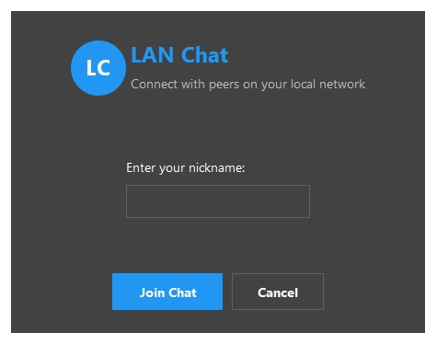
16.2 Command Execution & System Feedback via Slash Commands
This output showcases the use of special “slash commands” built into the system, enhancing usability for tech-savvy users. Commands like /help, /theme, /time, /netinfo, and /stats allow participants to interact with system-level features:
/stats: Shows TX/RX message stats.
/theme: Displays or toggles the current theme.
/netinfo: Dumps detailed interface metadata.
This console-style UX capability provides users with interactive control, which is especially valuable in secure or technical deployments.
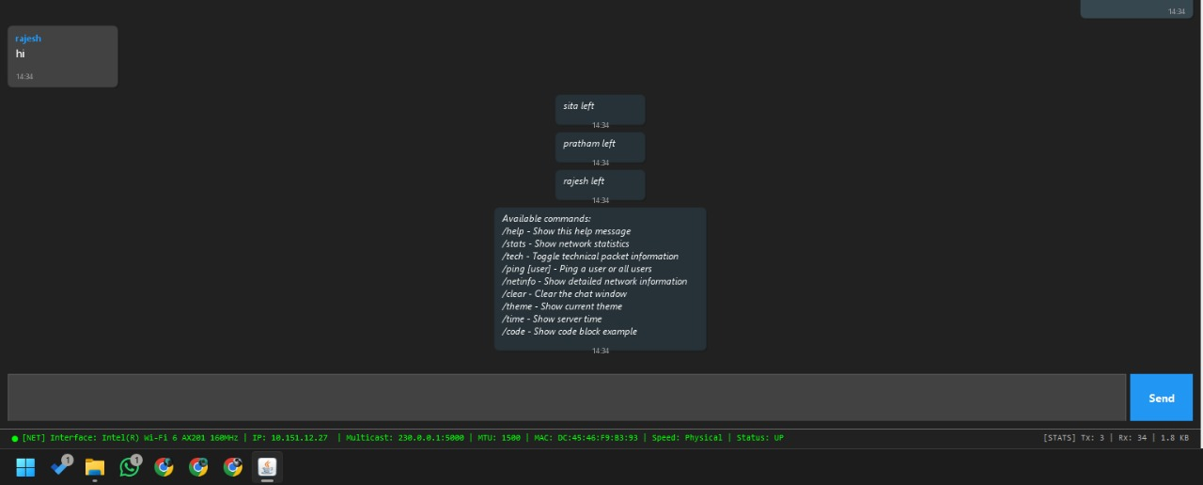

16.3 Multicast Group Chat with Four Participants
Here we demonstrate a full-scale LAN group chat with four users: “pratham,” “sita,” “rajesh,” and “om.” The left and right windows display the app running simultaneously on different machines. The synchronized chat history, consistent user lists, and GUI updates verify that:
The multicast channel is working as intended.
Each node receives the same packets.
The GUI updates are uniform across instances.
This also proves the scalability of the system for small LAN-based teams.

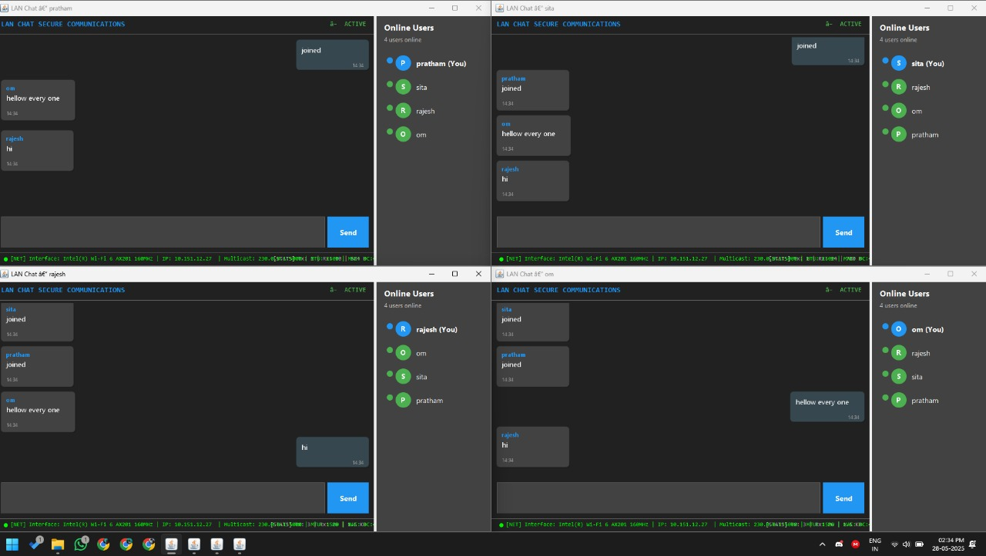

16.4 Single User Interface with Network & Status Indicators
This output represents the interface when only one user, “rajesh,” is present in the chat. The right-hand side displays the active user list with just the current participant. The status bar at the bottom shows live network metadata including multicast address, MAC address, IP, and interface status. This visual confirms successful GUI rendering, user registration, and socket-level readiness on the network.

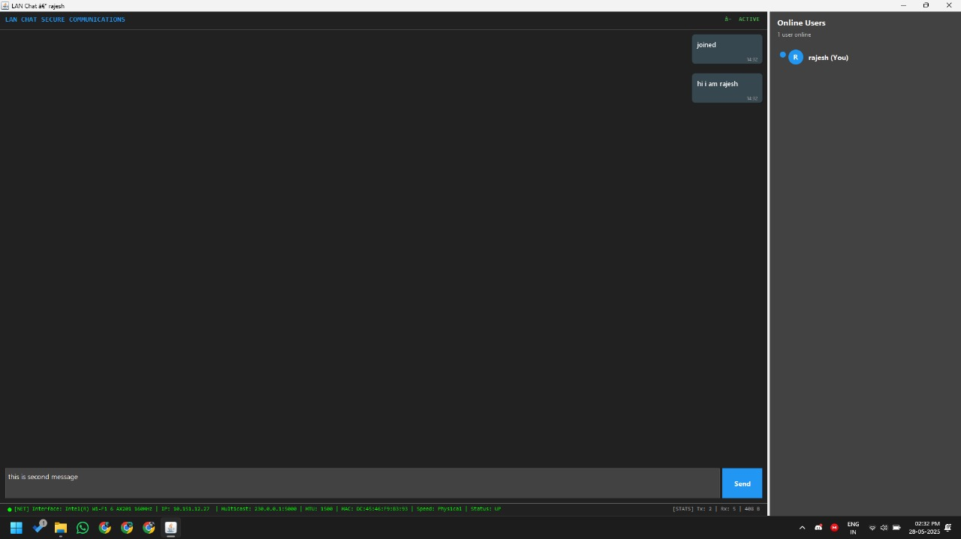

16.5 Two Users Communicating in Real-Time
This image illustrates a basic real-time chat session between two users, “rajesh” and “om.” Each message is encrypted before transmission and decrypted upon receipt. The message bubbles show user-specific alignment, while the online user list dynamically reflects presence. This test verifies that messages are successfully exchanged over the multicast group and rendered correctly per user.
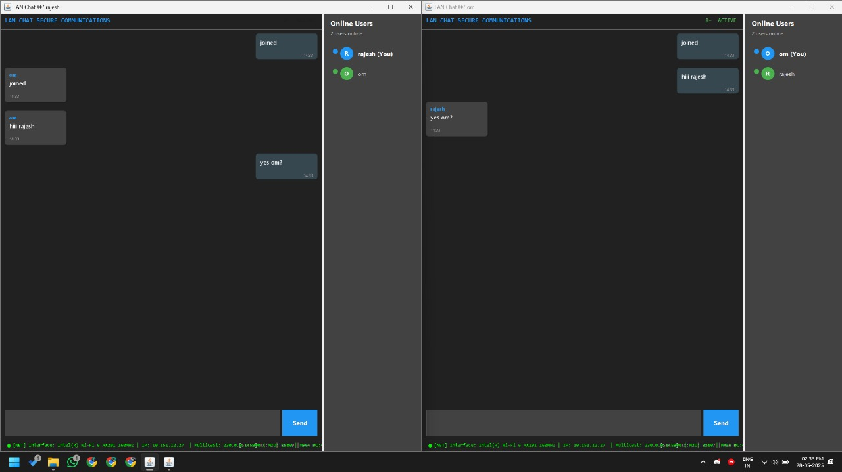

Chapter 17
Conclusion
17.1 What We Achieved
The Encrypted Multicast Chat System successfully delivers a decentralized, secure messaging platform tailored for local area networks. Our primary goal—to build a lightweight, server-free group chat solution—was met by combining peer-to-peer networking, cryptographic protection, and a user-friendly interface.
Using Java's MulticastSocket API alongside AES encryption, we enabled efficient message distribution to all connected participants while safeguarding message confidentiality and data integrity. The application’s architecture is component-driven, with well-defined modules like MulticastManager, EncryptionUtils, and ChatPanel, which together ensure maintainability, readability, and ease of future expansion.
On the frontend, JavaFX powers an intuitive, responsive interface that supports live chat updates, real-time user tracking, and theme toggling. The design remains minimalistic yet functional, aligning with the goal of low-resource usage and broad accessibility.
This project showcases Java's capability to support secure, real-time, offline communication solutions well-suited for educational, organizational, or institutional use cases.
17.2 Lessons Learned
Building this system offered rich insights into integrating networking, cryptography, and interface design into a cohesive Java application. A key takeaway was learning how to effectively manage concurrency—especially using Java threads alongside Platform.runLater() to handle UI updates without causing interface lag or crashes.
We also gained practical experience navigating the nuances of Java’s multicast capabilities. Differences in platform support and network permissions required thoughtful handling to ensure cross-device compatibility. Implementing AES encryption reinforced our understanding of cryptographic fundamentals like block modes, padding schemes, and secure key usage within decentralized systems.
On the design side, we realized the importance of creating intuitive interfaces that cater to both technical and non-technical users. Minimal design choices contributed significantly to usability and overall experience. Architecturally, maintaining a modular codebase proved beneficial for debugging, testing, and iterative improvements.
These combined experiences will greatly influence our future projects, especially those dealing with real-time communication, data security, and scalable software architecture.
17.3 Real-World Impact & Next Steps
Building this system offered rich insights into integrating networking, cryptography, and interface design into a cohesive Java application. A key takeaway was learning how to effectively manage concurrency—especially using Java threads alongside Platform.runLater() to handle UI updates without causing interface lag or crashes.
We also gained practical experience navigating the nuances of Java’s multicast capabilities. Differences in platform support and network permissions required thoughtful handling to ensure cross-device compatibility. Implementing AES encryption reinforced our understanding of cryptographic fundamentals like block modes, padding schemes, and secure key usage within decentralized systems.
On the design side, we realized the importance of creating intuitive interfaces that cater to both technical and non-technical users. Minimal design choices contributed significantly to usability and overall experience. Architecturally, maintaining a modular codebase proved beneficial for debugging, testing, and iterative improvements.
These combined experiences will greatly influence our future projects, especially those dealing with real-time communication, data security, and scalable software architecture.

